HALF ADDER USING NAND-BASED LOGIC GATES

1. Objective
To design and simulate a half adder using custom XOR and AND gate modules implemented from NAND gates in Verilog HDL, and verify its functionality through behavioral simulation and FPGA synthesis in Xilinx Vivado.

2. Theory
A half adder is a combinational logic circuit that adds two single-bit binary inputs, A and B, to generate two outputs: Sum (S) and Carry (C).
The Sum output is generated using the custom XOR gate module, while the Carry output is generated using the custom AND gate module. Both modules reuse the NAND-based logic gates developed previously.
During FPGA synthesis, Vivado optimizes the hierarchical design into LUT-based logic. The synthesized circuit uses separate LUTs for the Sum and Carry outputs.

3. Boolean Equations
Sum:
S = A ⊕ B
Carry:
C = A · B

4. Truth Table — Cell Properties

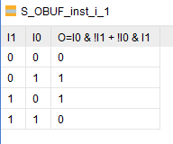

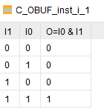

5. Simulation Waveform

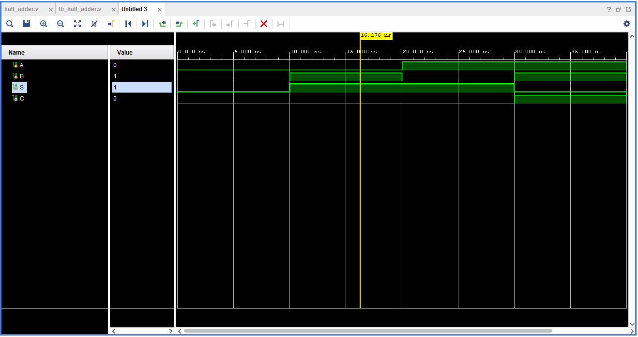

6. Synthesized Schematic

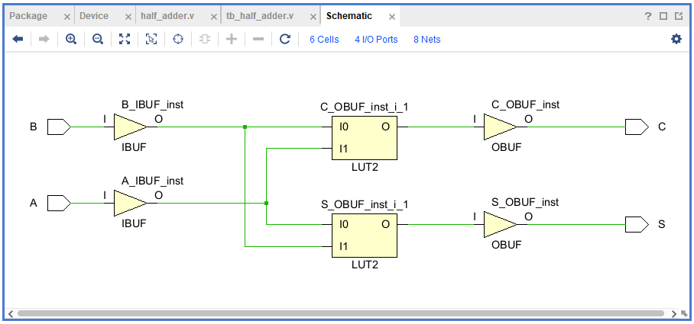

7. LUT INIT Value
Carry LUT — C_OBUF_inst_i_1
Observed INIT: 4'h8
Binary value: 1000
This implements the AND function, producing 1 only when both inputs are 1.
Sum LUT — S_OBUF_inst_i_1
Observed INIT: 4'h6
Binary value: 0110
This implements the XOR function, producing 1 when the two inputs are different.

FULL ADDER USING NAND-BASED LOGIC GATES

1. Objective
To design and simulate a full adder using custom half-adder and OR gate modules implemented from NAND-based logic gates, and verify its functionality through behavioral simulation and FPGA synthesis in Xilinx Vivado.

2. Theory
A full adder is a combinational logic circuit that adds three single-bit binary inputs: A, B, and the carry-in (Cin). It generates two outputs: Sum (S) and Carry-out (Cout).
The design uses two instances of the previously developed half-adder module. The first half adder adds A and B, while the second adds the intermediate sum to Cin. An OR gate combines the two intermediate carry outputs to generate Cout.
During FPGA synthesis, Vivado optimizes the hierarchical logic into LUT-based logic. The synthesized design contains separate LUTs for the Sum and Carry-out functions.

3. Boolean Equations
Sum:
S = A ⊕ B ⊕ Cin
Carry-out:
Cout = (A · B) + (Cin · (A ⊕ B))

4. Truth Table — Cell Properties

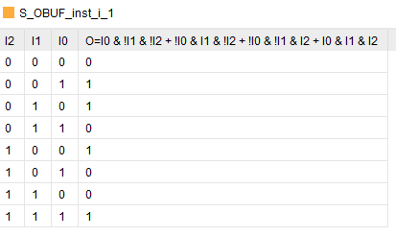

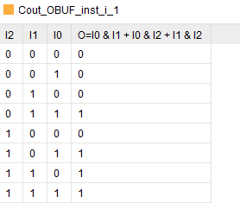

5. Simulation Waveform

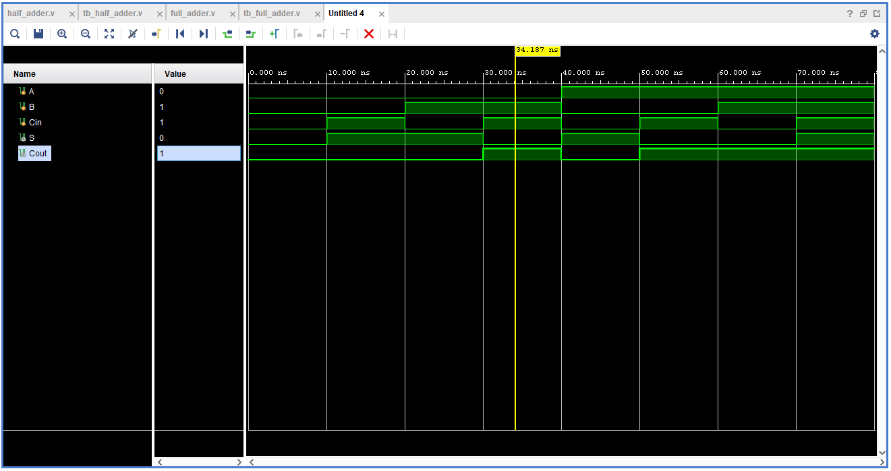6. Synthesized Schematic
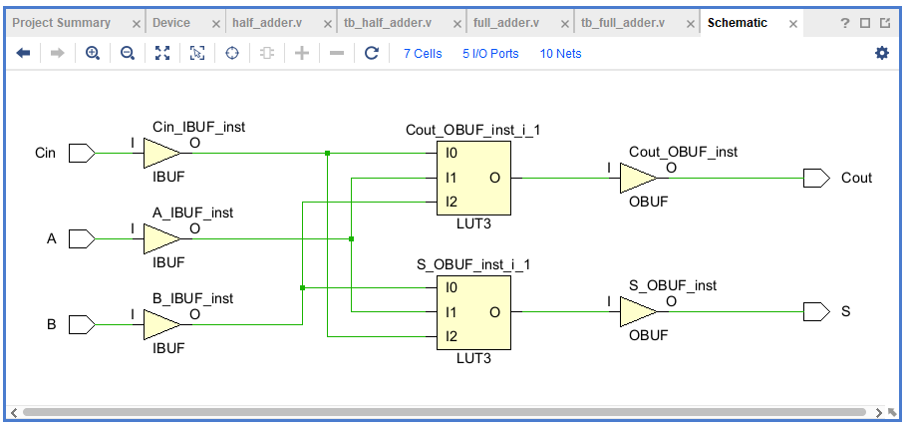.

7. LUT INIT Value
Carry-out LUT — Cout_OBUF_inst_i_1
Observed INIT: 8'hE8
Binary value: 11101000
This LUT implements the full-adder Carry-out function.
Sum LUT — S_OBUF_inst_i_1
Observed INIT: 8'h96
Binary value: 10010110
This LUT implements the full-adder Sum function, producing 1 when an odd number of the three inputs are 1.

